**NAME: VIJAYAN.N**

**DEPARTMENT: IT**

**REG.NO: 501421205058**

**COURSE: ANGULAR.JS**

**ASSIGNMENT: REGRISTRATION HTML TASK-1**

**DATE: 05/12/23**

**Student Details**

<!DOCTYPE html>

<HTML>

    <body>

    <center>

    <h1 style="color: brown;">Student application</h1>

    <form action="regform.html"method="POST">

        <div><br>

        <label for="mail">EMAIL ID:</label>

        <input type="text"id="mail"name="mail_id"value=""placeholder="mail"required><br>

        </div>

        <div><br>

            <label for="password">PASSWORD:</label>

            <input type="text"id="mail"name="mail_id"value=""placeholder="password"required><br>

        </div>

        <br>

        <button type="button">Login</button>

        <button type="reset">cancel</button>

        <p>not have a account?</p>

        <button type="submit">CreateAccount</button><br><br>

        <br>

        <br>

        <br>

    </form>

</center>

</body>

</HTML>

<style>

    form{

        border: 5px solid brown;

        margin-bottom: 20px;

    }

</style>

SAMPLE LOGIN FORM

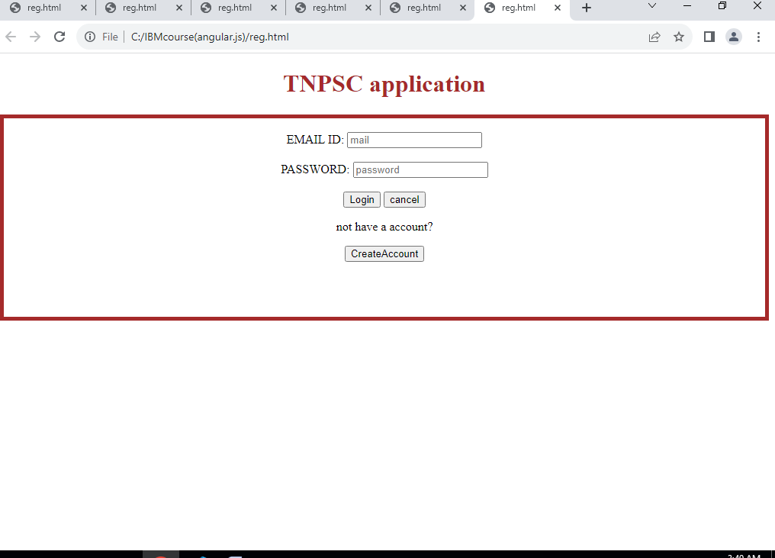

Sample output for login form

Sample Regristration code

<html>

</html>

<body style="background-image: url('download.jpg');background-size: cover;">

    <center>

<h1 style="color: brown;">New Regristration</h1><br><br>

    <form action="thank.html"method="POST">

        <div style="box-sizing: border-box;border-width: 0lvb;" >

        <div style="display: flexbox;">

        <label for="fname"><b>First name:</b></label>

        <input type="text"id="fname"name="fname"><br><br>

        <label for="lname"><b>Last name:</b></label>

        <input type="text"id="lname"name="lname"><br><br>

        </div>

        <div style="content: normal;">

        <label for="age"><b>Age:</b></label>

        <input type="text"id="age"name="age"><br><br>

        </div>

        <div>

        <label for="deg"><b>Degree:</b></label>

        <input type="text"id="deg"name="deg"><br><br>

        </div>

        <div>

        <label for="gender"><b>Gender:</b></label>

        <input type="radio"id="male"name="gen"value="Male">

        <label for="Male">Male</label>

        <input type="radio"id="female"name="gen"value="Female">

        <label for="Female">Female</label><br><br>

        </div>

        <div>

        <label for="Address"><b>Address:</b></label>

        <input type="text"id="address"name="adrs"value=""><br><br>

        <label for="phone"><b>Mobile no:</b></label>

        <input type="text"id="phone"name="mobile"value=""><br><br>

        </div>

        <button type="submit">submit</button>

        <button type="reset">cancel</button>

        </div>

    </form>

</body>

</html>

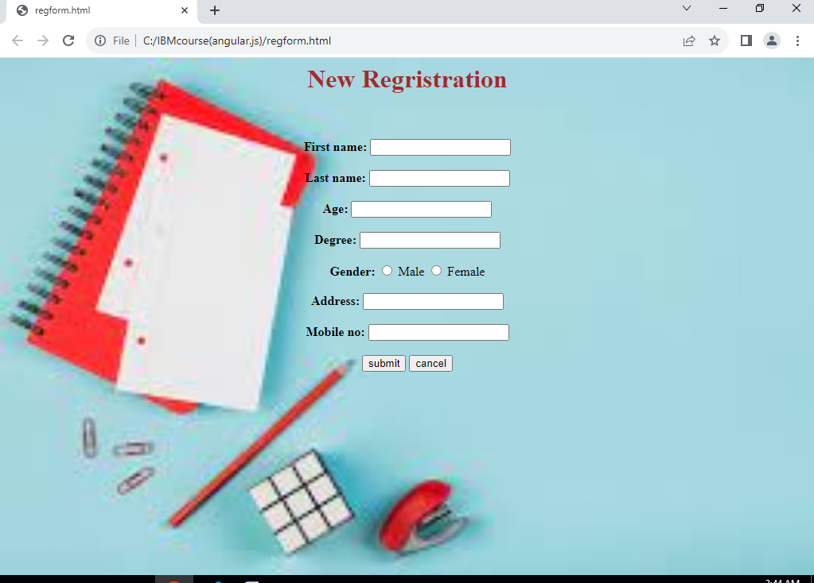

Sample registration output

<!DOCTYPE html>

<html>

    <head>

        <title>my form page</title>

    </head>

    <body>

        <h1>Thank you for submitting</h1>

    </body>

</html>

Output:

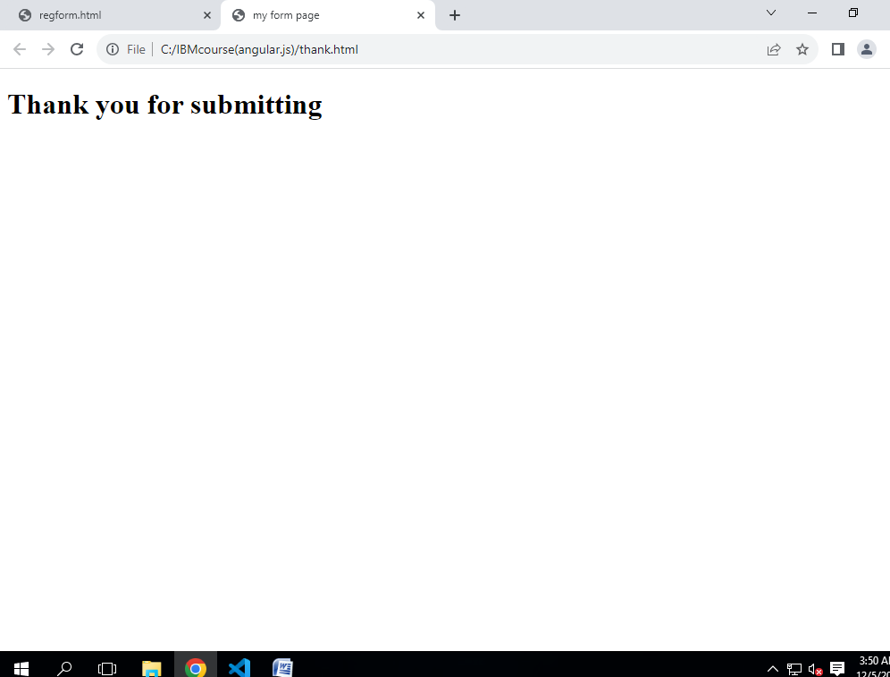

Sample page after completing registration